Skeleton post processing
To allow for the machine learning algorithm to read user movements, skeleton post processing was proposed by the client.

Skeleton post processing is a process of simplifying image or video footage to find key points of objects to allow for easy interpretation for programs. The created program was made to clean up and simplify video footage of a person to allow for easier interpretation of a person’s movements by a deep learning algorithm.

Libraries used:
- Opencv: provides computer vision and image processing (https://www.geeksforgeeks.org/python/python-play-a-video-using-opencv/ )

- Ultralytics YOLO: YOLO is a real object detection algorithm that is used to identify objects in video and pictures. ( https://docs.ultralytics.com/ )

- Numpy: python library for fast numerical computations

Video input
The current version of the program takes a predefined file input using cv2.VideoCapture from the opencv library. This will simply take the video and allow python to access it.
It is then output one frame at a time in a while loop.
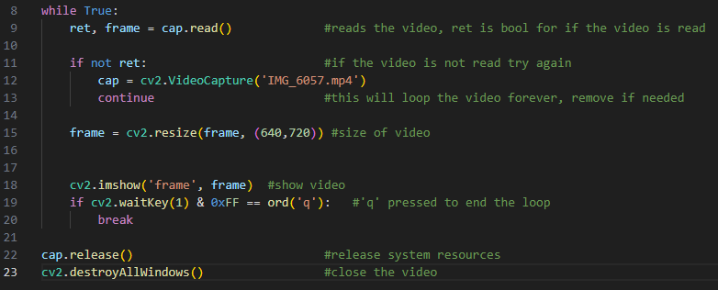
The video will loop indefinitely so an output has been added. Pressing q will end the program.

When the code is run, a window will open with the input video/ picture displayed on it.
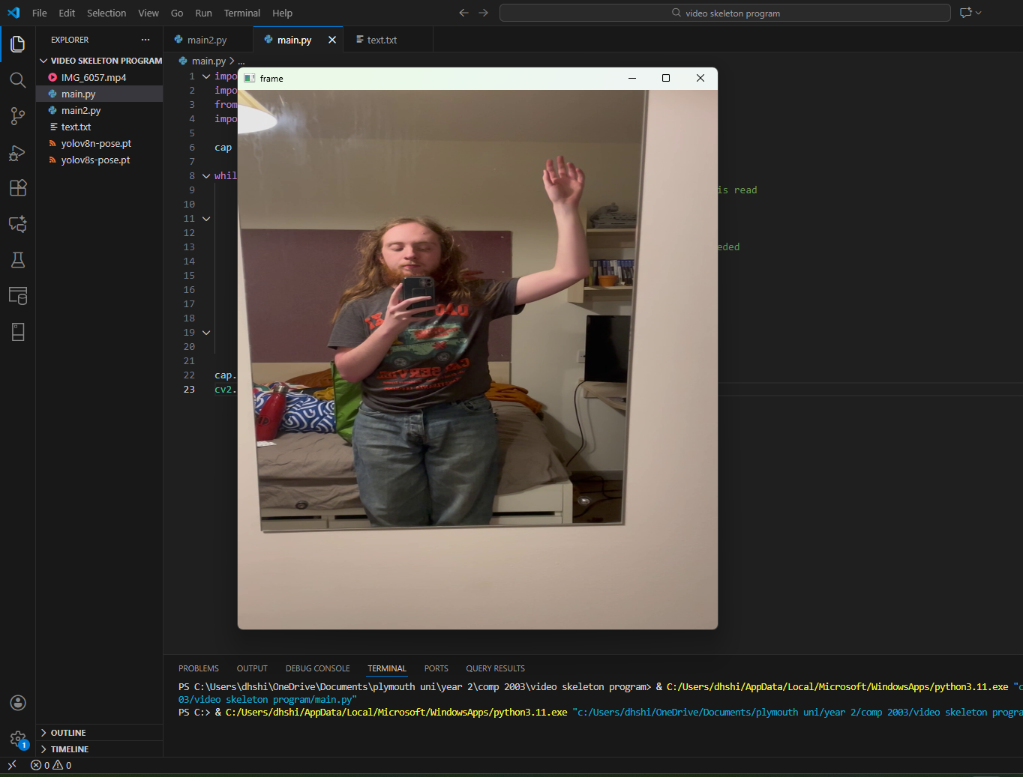

Adding the model
To add the model of YOLO, you simply add this line:
The text in the brackets is the name of the version of the yolo model you want to use. Then in the while loop add these 2 lines:
The first line is using the model to read the current frame of the video and find the key points of the person in the video. The second line is plotting them over the original video.
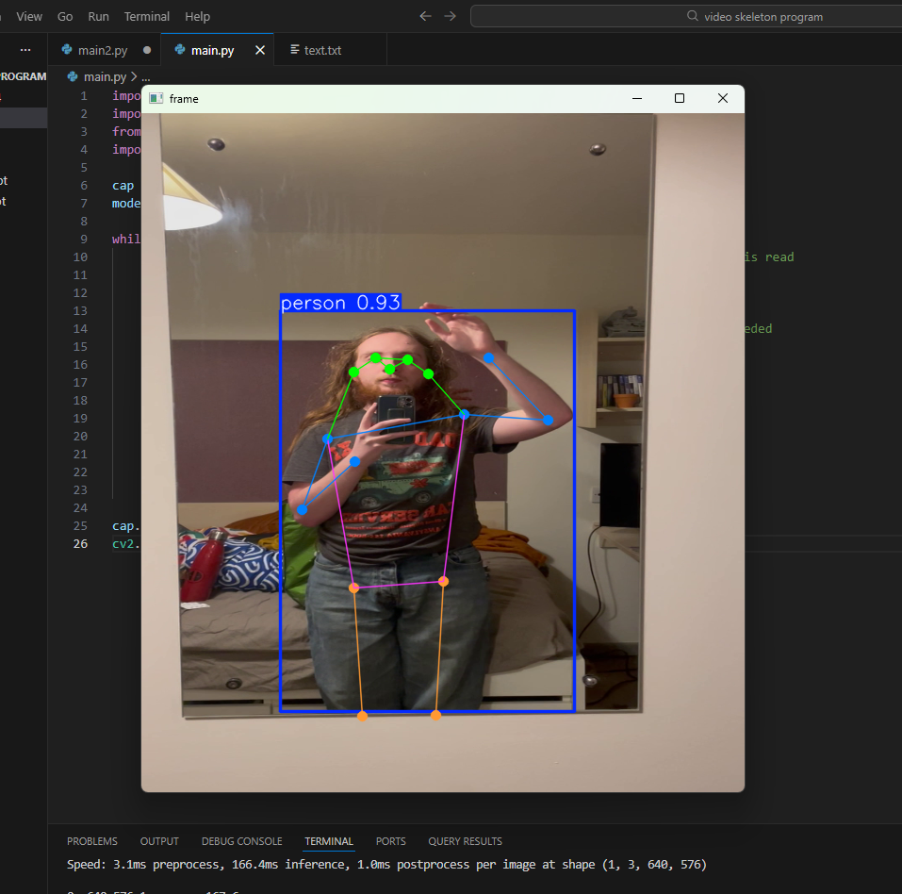
Each dot on the skeleton is key point being tracked. Each key point is allocated a number based on what it is tracking: (reference)
Number | Key point
0 | Nose
1 | Left eye
2 | Right eye
3 | Left ear
4 | Right ear
5 | Left shoulder
6 | Right shoulder
7 | Left elbow
8 | Right elbow
9 | Left wrist
10 | Right wrist
11 | Left hip
12 | Right hip
13 | Left knee
14 | Right knee
15 | Left ankle
16 | Right ankle
Table 1: indexes of key points and what they track

Removing the background footage
Next part as to plot the key points on to a blank image. This will improve the readability of the key points.
This code creates a blank image background for the skeleton to be placed over.
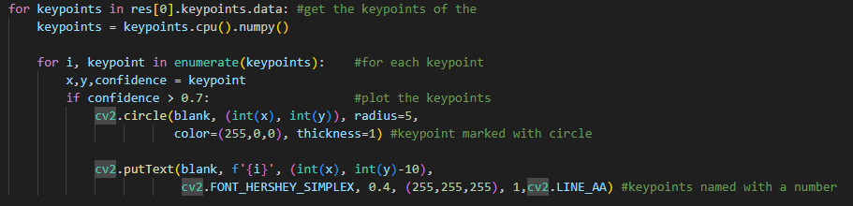
This code gets all of the key points and plots them as circles onto the blank image. It will also annotate each point with its respective number (see table 1).
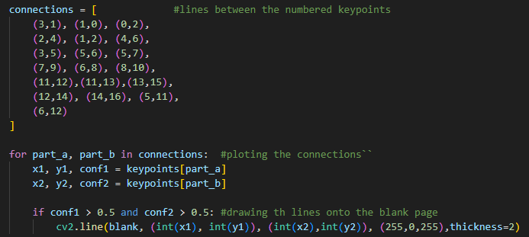
This code points out all of the connecting points with the connections array. This will be used to connect all of the key point together to create that outline from the original process. It will then get the coordinates of the points and draw a line between the 2 of them.

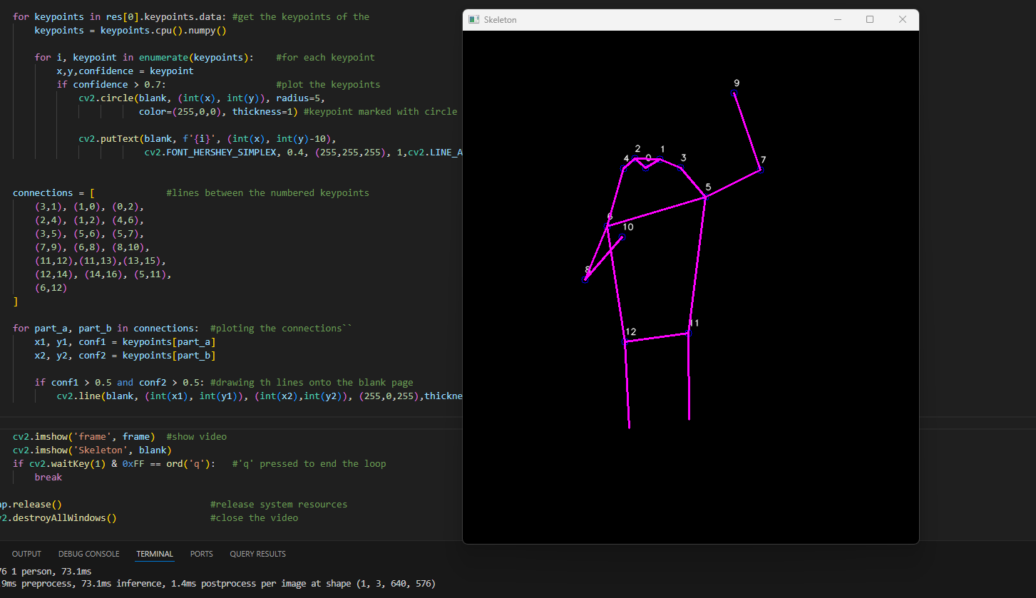

References:
- https://docs.ultralytics.com/tasks/pose/ - pose estimation documentation

